Let T be a weighted binary tree. For example, a weighted binary tree is shown below. The numbers on the arcs are the arc lengths ( or weights).

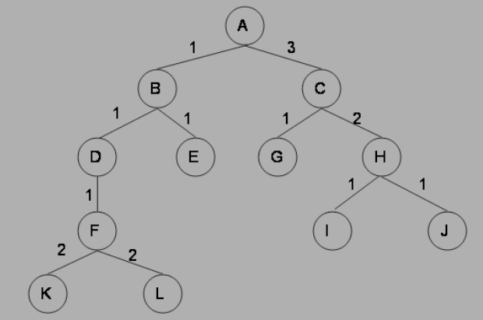

What order would the states be expanded by the Uniform Cost Search? Stop when you expand the goal state G. Write an algorithm and subsequent Pyhton(or C++) code to display lowest cost path from start node A to goal node G

Input format

Enter the height ‘h’ of binary tree

One dimensional matrix of size 2^(h+1)-1

Output format

Print lowest cost path initial node to goal node

Print total cost

Input

2

0 4 2 1 1 3 1

output

2 1

3

Input

3

0 20 1 3 4 5 1 1 3 5 4 1 4 3 2

output

1 1 2

4